8/30/2018

**CS 146**

**Intro to the Web I: TCP/IP & DNS**

Server Webs

The client server model

* This works upon a request-response loop
  + The client sends a request to the server, and the server returns a response

Peer to Peer Alternative

* Rather than a single computer containing all of the data, data is distributed amongst several devices on a peer to peer network
  + Torrenting and such

Servers are a gigantic web of parts by which servers communicate with each other across broad

TCP/IP

These protocols have been implemented in every operating system and make fast web development possible. There are multiple layers of internet protocols-

* Link Layer: Responsible for physical transmission of raw bits
  + MAC
* Internet Layer: Establishes connection, routing, and addressing
  + IPv4, IPv6
* Transport Layer: Ensures transmissions arrive in order and without error
  + TCP, UDP
* Application Layer: High protocols that allow applications to interact with transport layer
  + HTTP, FTP, POP, etc.

Link Layer

* Responsible for the physical transmission of data across media (both wired and wireless) and establishing logical links
* It handles issues like packet creation, transmission, reception, error detection, collisions, line sharing, and more

Internet Layer

* The internet layer provides “best effort” communication
  + Does not guarantee that data itself will get there but will set up a connection. Doing so will greatly hinder performance.
* Makes use of IP addresses
  + The IP address is the actual identifier used to name each device on a network, comprising of multiple digits

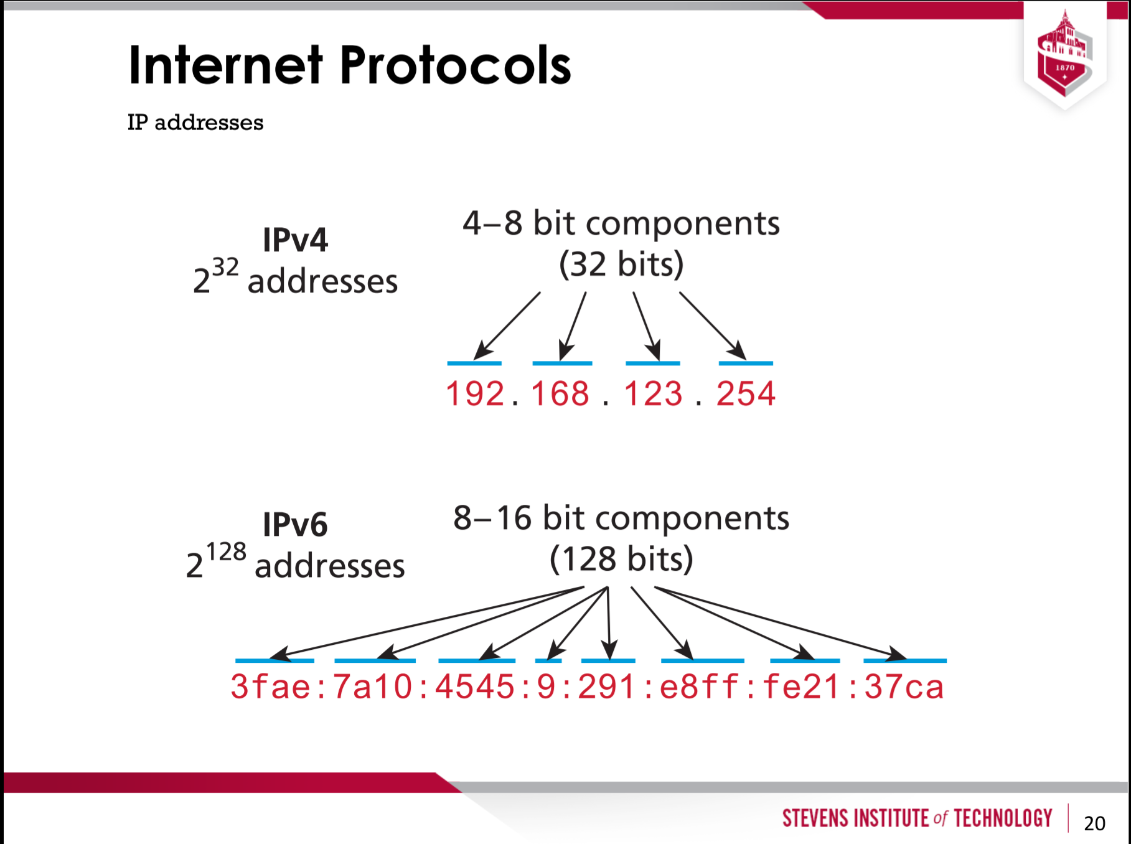

Transport Layer (TCP)

* Ensures transmission arrive in order and without error
* The TCP will index all the data, making sure that the data fills in properly. If the data is missing, the TCP will ask the server again for the same data.

Application Layer

There are **many** application layer protocols. Web developers should be aware of:

* HTTP: The Hypertext Transfer Protocol is used for web communication
* SSH: The Secure Shell Protocol allows remote command line connections to servers
* FTP: The File Transfer Protocol is used for transferring files between computers
* POP/IMAP/SMTP: Email-related protocols for transferring and storing email
* DNS: The Domain Name System protocol used for resolving domain names to IP addresses